Country (AU, CA, UK) Press Release Page Template

This template is used for press release overview page for all country (AU, CA, UK).

For E.g.

AU press release overview – **AU Press Release Page**

[**https://www.ancestry.com/corporate/ancestry-releases-first-impact-report-0**](https://www.ancestry.com/corporate/ancestry-releases-first-impact-report-0)

CA press release overview – **CA Press Release Page**

[**https://www.ancestry.com/corporate/ancestry-releases-first-impact-report-1**](https://www.ancestry.com/corporate/ancestry-releases-first-impact-report-1)

UK press release overview – **UK Press Release Page**

[**https://www.ancestry.com/corporate/ancestry-makes-over-12-million-historic-uk-newspaper-pages-available-newspaperscom**](https://www.ancestry.com/corporate/ancestry-makes-over-12-million-historic-uk-newspaper-pages-available-newspaperscom)

Basic Tab

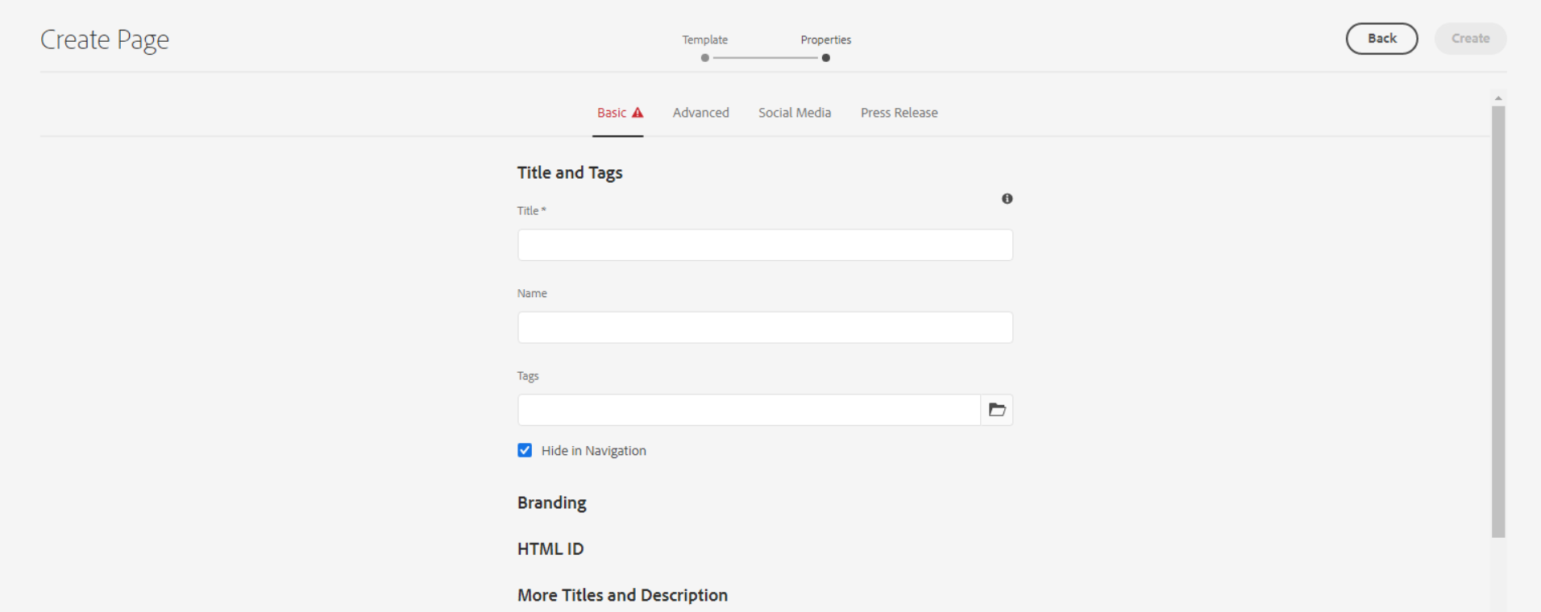

**Title** – Defines the page meta title for SEO, as well as a title displayable in the page content (unless an overriding 'Page Title' is defined).

**Name** – It should be the page name.

**Tags** – Defines the page meta tag for SEO

**Checkbox for Hide in Navigation** – This is for hide the page from header navigation.

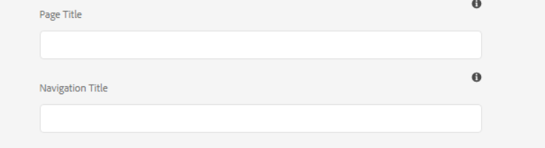

**Page Title** - Defines a page title that is displayable in the page content, instead of the 'Title'.

**Navigation Title** - Defines a navigation title that is displayed in site navigation menus, instead of the 'Page Title' or 'Title'.

Advanced Tab

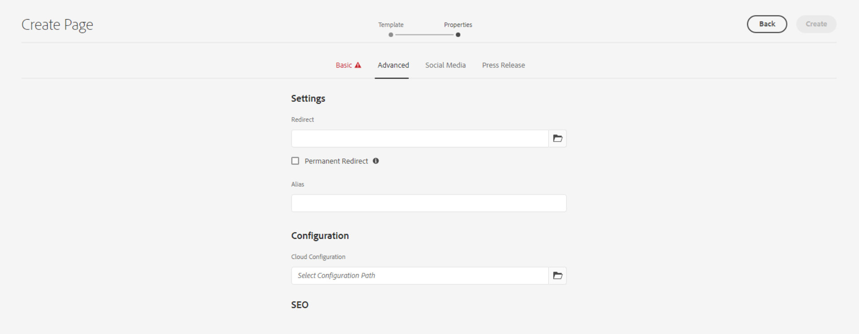

**Redirect** – Here we can set the internal or external redirect path

**Checkbox for Permanent Redirect** – can be checked to enable Permanent Redirect.

Social Media Tab

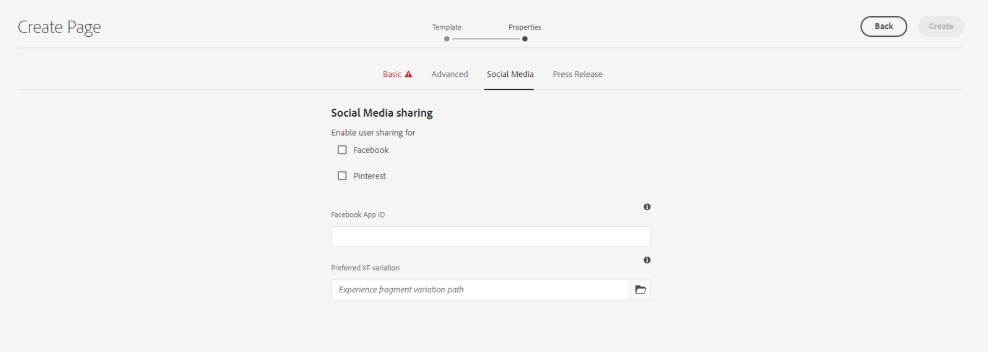

This is for social media Sharing.

Press Release Tab

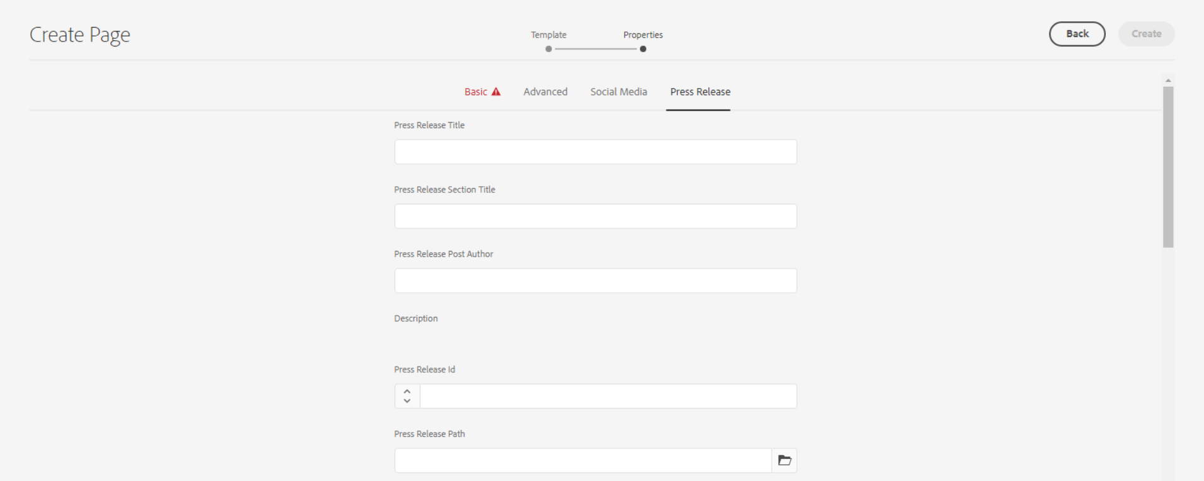

**Press Release Title** – This is for blog title.

**Press Release Section Title**

**Press Release Post Author -** This is for author name will be visible in hero banner caption section.

**Description -** This field is required for search your press-release in search page. We need to update here meta description or first 2-3 lines from your page body description part.

**Press Release Id**

**Press Release Path**

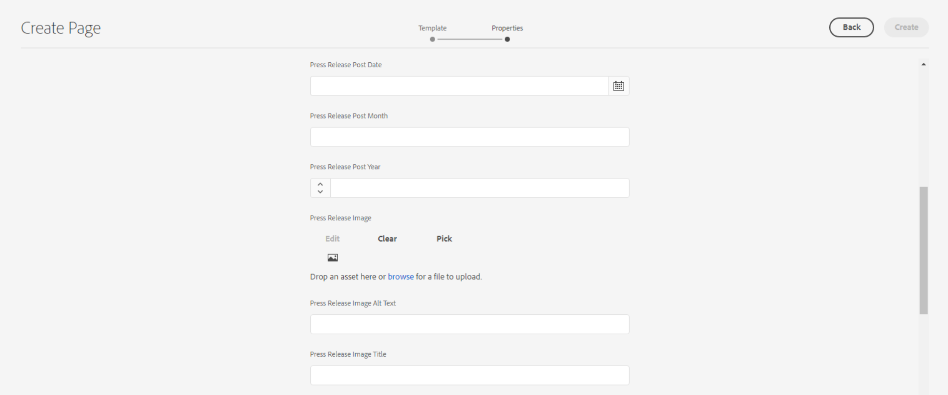

**Press Release Post Date -** This is for postdate will be visible in hero banner caption section.

**Press Release Post Month** – This is for month of press-release post

**Press Release Post Year** – This is for year of press-release post

**Press Release Image**

**Press Release Image Alt Text**

**Press Release Image Title**

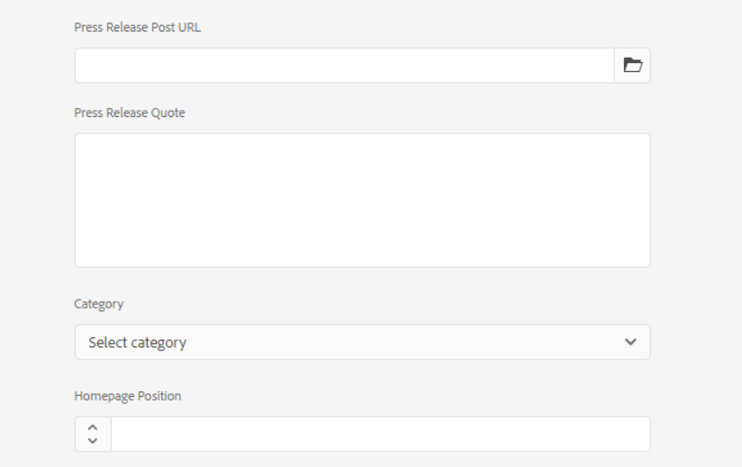

**Press Release Post URL**

**Press Release Quote**

**Category**

**Homepage Position**